SOC 2000 Assessment 3
Social Activism and Data Analysis
Student Name
Institution Affiliation

Social Activism and Data Analysis
Mock Blog: Institutional Discrimination in the Criminal Justice System
Different forms of discrimination have been to existence even before the creation of this great nation. Racial discrimination has been faced in all economic sectors, including the healthcare industry, industrialization industry, and even at the federal level, especially during politics (Block, 2013). Considering racial discrimination, there have always been the dominant groups and the minority groups, which are most discriminated against. When it comes to matters of law, the minority groups, including the Asians, Latino, and the African-Americans, have been losing the side of the law since they are much discriminated by law as compared to the dominant groups that are the whites. When this great nation was struggling for independence, strict rules were to exist that discriminated against the blacks and other minority groups from several elements of life. Although the constitution came to the recognition of the minority races and eradicated open racial communication, this nation is still struggling with instances of racial discrimination, especially when it comes to laws related to fighting on drugs. The US prisons have a large number of violent and drug crimes prisoners being the minority races. This paper will precisely address discrimination in the criminal justice system and how it impacts the minority groups. Sociological factors and disparities in their impacts on demography will be addressed. I will also address the proposed policy changes and how these changes will affect the possible impact of discrimination in institutions.
Drug Policies and Minority detention Injustices
American jails and prisons have more blacks as compared to those in universities and colleges (Drug War Facts, 2019). Black Americans are arrested at a rate that is twice as high as the rate at which white Americans are arrested. These rates are much alarming, considering that the whites use drugs more than the blacks. Below is a brief graphic description of the drug-related arrest rate by race.
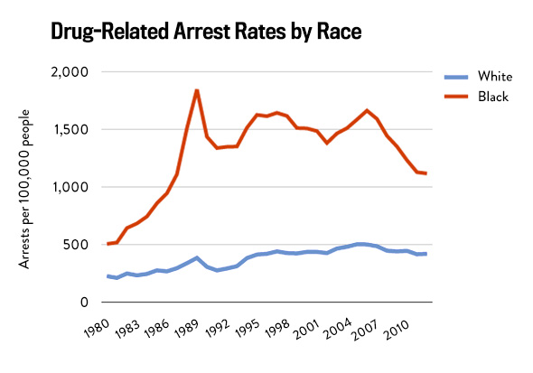
Most of the institutions constituting the justice system, including the police stations and courts, have a negative perception towards the Blacks and other minority groups hence association most criminal activities with them even sometimes when innocent. In the greatest war towards drug policies, the greatest targets are the minority groups such as the Latinos and the African-Americans, even in situations where they are not involved. The harsh policies on the war on drugs have ended up sending more blacks to jail hence increasing the number of blacks in prisons.
Generally, institutional discrimination and the criminal justice system is evidenced by how the judiciary system usually discriminates against some races instead of doing justice to all and ascertain the cause of the problem and jail the right person. A research carried out by Fielding-Miller, Davidson, & Raj (2016) depicts that the judicial system does not make the necessary investigations when it comes to matters related to substance abuse hence most Latinos and African-Americans end up in jail wrongly. In rods, Blacks are most likely to be pulled out and have their cars searched. Due to the affordability of legal assistance and bails, most blacks end up staying more in jails as they wait for trials as compared to white. This is evidenced by the graphical representation below.
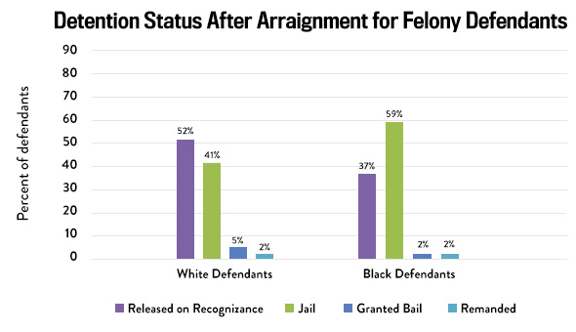
The above statistics clearly demonstrate the existence of criminal justice systems inequality between the blacks and the whites.
Drug Use and Racial Statistics
There are several sociological theories that can be used to describe this institutional inequality in the criminal justice system. Critical Race Theory is one of the theories that seek to help social-legal scholars find out how different races are likely to behave. Having the US as a white supremacy country, this theory is used in a racial prejudice; hence the minority races are always in the losing end (Drug War Facts, 2019). Most of the war on drugs policies are created with this theory in mind hence making the whites to dominate, and most of the minority groups end up being crime victims and get jailed.
The current society, in one way or the other, promotes racial discrimination in the war on drugs, sue to the imperative historical injustice caused by racial profiling. As mentioned earlier, different drug researches have proven that we have many whites using drugs as compared to blacks. For instance, in 2016, there were approximately 91,960 whites who used drugs as compared to 16,544 Latinos and 14,825 African-Americans (AP-NORC, 2019). Narrowing down to specific usage of marijuana, it was noted that about 84,639 whites used marijuana as compared to 14,055 Latinos and 13,445 African-Americans. Surprisingly enough, the number of blacks arrested in the same year over drug usage was more than the whites. The report given by the FBI via the Uniform Crime Report much differed from the figures of the individuals who went to jail. The report depicted that more whites (approximately 881,885) were arrested as compared to Blacks (approximately 332,131) (FBI Uniform Crime Report, 2016). However, in the long run, more blacks went to jail than whites. The figure below is a summary of drug use statistics.
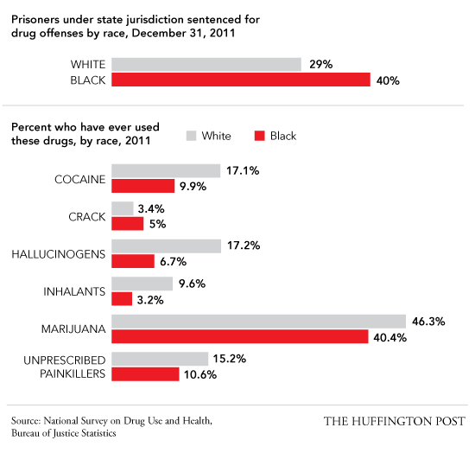
The National Survey on Drug Use and health depicts that the number of people using illicit drugs is high among the whites, although the minority groups are mostly arrested. For instance, statistics depict that 48.9% of whites have ever used marijuana, while blacks are 42.1%, Asians are 17.8%, and Latinos 32.55% (ICPSR, 2013a). Considering other drugs such as cocaine and heroin, the same statistics depict high use among whites than minority populations. The figure below is a graphical representation of the comparison between drug use and drug arrest and detention hence depicting racial discrimination in the Drug war.
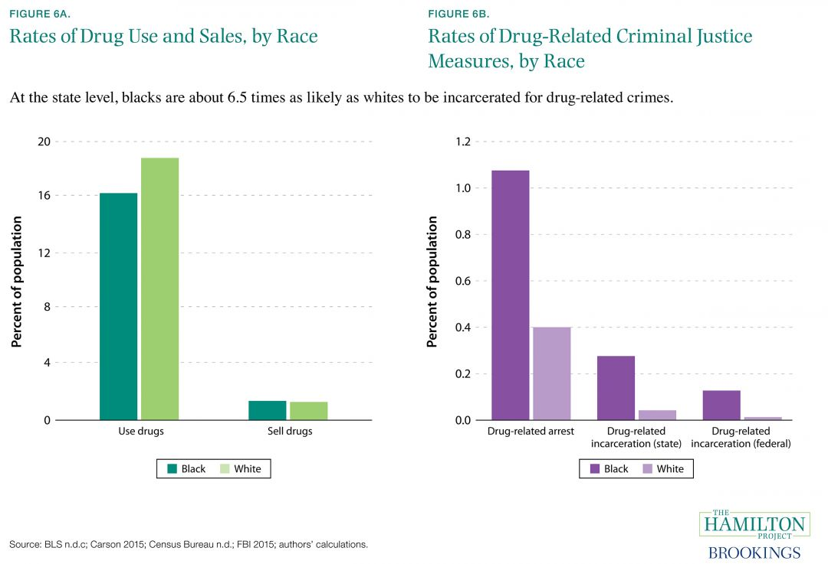
Factors Contributing to Racial and Ethnic Disparities within the Criminal Justice System
The existence of biased war on drug policies is one of the factors that has led to an increased rate of discrimination among minority races. Usually, the society has several presumptions that are much different from the facts hence end up branding the minority races as the “criminal races." The whites are never assumed to be drug criminals due to their supremacy. According to Rosino & Hughey (2018), the US faces high rates of institutional discrimination, which is well evidenced by the difference between the number of drug arrests and the individuals who go to jail.
Minority races often get biased treatments since the American Criminal Justice is built upon discriminatory Laws and policies. The biasness of the laws makes blacks to face discrimination at every stage of criminal justice often. Prejudice laws make most of the blacks to be convicted due to violation of drug policies hence end up being jailed.
How Public Policies are linked to Racial and Ethnic Disparities
Most of the public policies on the war on drugs are associated with racial profiling hence being linked with racial discrimination in the criminal justice system. Since the 1970s, most public policies on drugs are incorporated with elements of race and gender hence making the minority groups always fall victim to drug crimes (Gaston, 2019). The efforts that most presidents have made to reduce drug usage have made the laws on drugs tougher and targeting some races. Generally, many drug policies are racially based; the whites remain to be supreme, and our prisons are getting filled with the wrong people, mostly the minorities.
Impact of Institutional Discrimination on Minority Races
The worst impact of institutional discrimination in the criminal justice system is that the minority communities are facing a violation of their rights and civil liberty. Law officers are much biased, especially when looking for drug evidence when lacks are facing criminal justice. There is a perception that people have created connecting blacks with drug crimes. For instance, when a police officer arrests a black and a white due to drug use, the evidence will most likely be pinned on the black victim. Most individuals from minority races end up in jail due to institutional discrimination (Koch, Lee & Lee, 2016). Discrimination also occurs on the jury level where blacks tend to be excluded from jury service, and 8 out of 10 blacks have been struck by prosecutors from serving on death penalty cases. This discrimination impacts the community on sentences and victim impact statements that are never heard by their community of peers.
Policy Strategies for Reducing Institutional Discrimination
The war on drug policies has hindered many Americans from achieving their American dream despite the US being a land of many opportunities and offering support to all citizens irrespective of their race and gender. Since the use of all current policies on drugs results in racial discrimination, the federal and state governments need to change the entire concept of the war on drugs and take different approaches. New policies should be implemented in the criminal justice system. For instance, a policy should be put in place to ensure that during patrols, all cars are searched irrespective of the race of the drivers and any evidence of drug crime well noted. Additionally, all the drug crimes should be treated equally and receive fair trials with proper clarifications of evidence provided. Generally, congress needs a tie to revise the current laws on the war on drugs. These laws need to be modeled without favoring any specific race.
Conclusion
In conclusion, since the implementation of the first anti-drug laws in the 1800s, racial discrimination has been faced in the war on drugs. It is the high time that every American recognizes the need for diversity. All institutions need to come up will policies that help support diversity. Recognition of diversity by all law officers could much help reduce instances of racial discrimination in the criminal justice system.

References
AP-NORC (2019). Crime and law enforcement in America: Racial and ethnic differences in attitudes toward the criminal justice system. Associated Press-NORC website. Retrieved from: http://www.apnorc.org/projects/Pages/HTML%20Reports/crime-and-law-enforcement-in-america-racial-and-ethnic-differences-in-attitudes-toward-the-criminal-justice-system0402-7262.aspx
Block, F. (2013). Racism’s hidden history in the war on drugs. Huffington Post website. Retrieved from: https://www.huffingtonpost.com/judge-frederic-block/war-on-drugs_b_2384624.html
Drug War Facts (2019). Illicit drug use and marijuana use in a lifetime, past year, and past month among persons aged 12 and older in the US by demographic characteristic: Numbers in thousands. Retrieved from: http://drugwarfacts.org/chapter/prevalence#overlay=table/nsduh_current
FBI Uniform Crime Report (2016). Arrests by race and ethnicity; Table 21A. FBI: UCR website. Retrieved from: https://ucr.fbi.gov/crime-in-the-u.s/2016/crime-in-the-u.s.-2016/topic-pages/tables/table-21
Fielding-Miller, R., Davidson, P., & Raj, A. (2016). Blacks face a higher risk of drug arrests in White neighborhoods. The International journal on drug policy, 32, 100.
Gaston, S. (2019). Enforcing race: A neighborhood-level explanation of black-white differences in drug arrests. Crime & Delinquency, 65(4), 499-526.
ICPSR (2013a). Quick Table: National survey on drug use and health. Results: Ever used heroin by race and ethnicity. Inter-University Consortium for Political and Social Research website. Retrieved from: https://www.icpsr.umich.edu/quicktables/quickoptions.do
Koch, D. W., Lee, J., & Lee, K. (2016). Coloring the war on drugs: arrest disparities in black, brown, and white. Race and Social Problems, 8(4), 313-325.
Rosino, M. L., & Hughey, M. W. (2018). The War on Drugs, Racial Meanings, and Structural Racism: A Holistic and Reproductive Approach. American Journal of Economics and Sociology, 77(3-4), 849-892.

